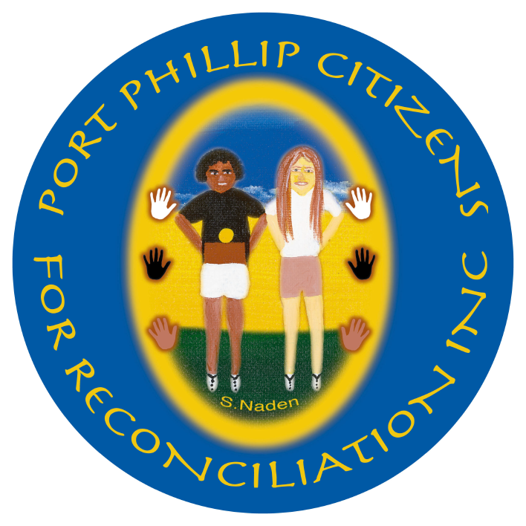
2014-15 Annual Report

Wominjeka – Welcome
Port Phillip Citizens for Reconciliation acknowledges the Traditional Owners of the land we meet on, the Yalukit Wilum clan of the BoonWurrung

ELECTIONS
During the last Annual General Meeting on
16 September 2014, the following officers were elected unanimously: Co-Chairs - Rosemary Rule and Dennis Fisher; Treasurer - Gael Wilson; Secretary - Sylvia Edgar.
My thanks to these dedicated people who attend meetings, oversee the schools program, assist with Mungo, help at public events and contribute in many other ways. Together, we make a great team. After the elections, we were privileged to hear from the legendary actor/playwright Jack Charles; surely one of the most inspiring speakers we’ve heard.

SCHOOL PROGRAMS
Over the past year, our work in local schools has flourished, largely due to the diligent work of Gael Wilson, Deb Stewart and Kerry O’Meara. We have received positive and very encouraging feedback. Peter ‘Judda’ Mackey, Leila Gurruwiwi, Declan ‘Gizmo’ Furber-Gillick Judith Jackson, Jim Poulter and Bea Edwards (Winja Ulupna Manager) have spoken with thousands of students, and teachers, at St Kilda Park PS, St Kilda PS, Elwood PS, Elwood SC, Albert Park College, Port Melbourne PS, CBC in St Kilda, Gowrie Victoria at Docklands, and South Melbourne Community Child Care Centre.

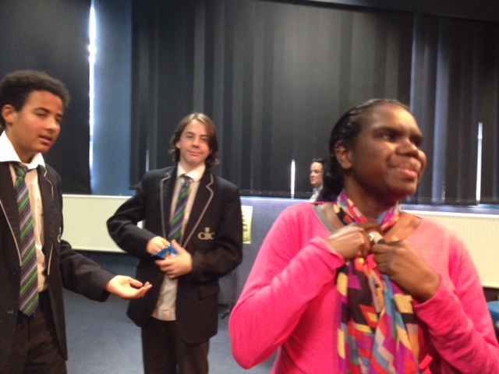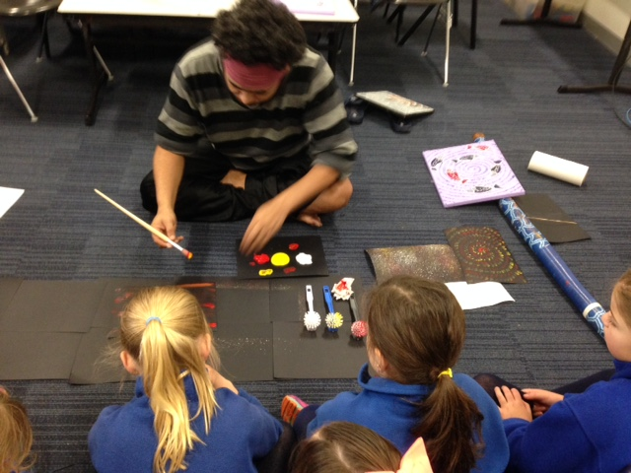
Leila Gurruwiwi at Christian Brothers (left) and Judda at Port Melbourne Primary School (right)

I wanted to thank you again for everything you are doing and providing to our school. The value of amazing people like Leila and Judda visiting and working with the children cannot be underestimated.
Darren Crawcour, Leading Teacher - Student Wellbeing, Port Melbourne Primary School 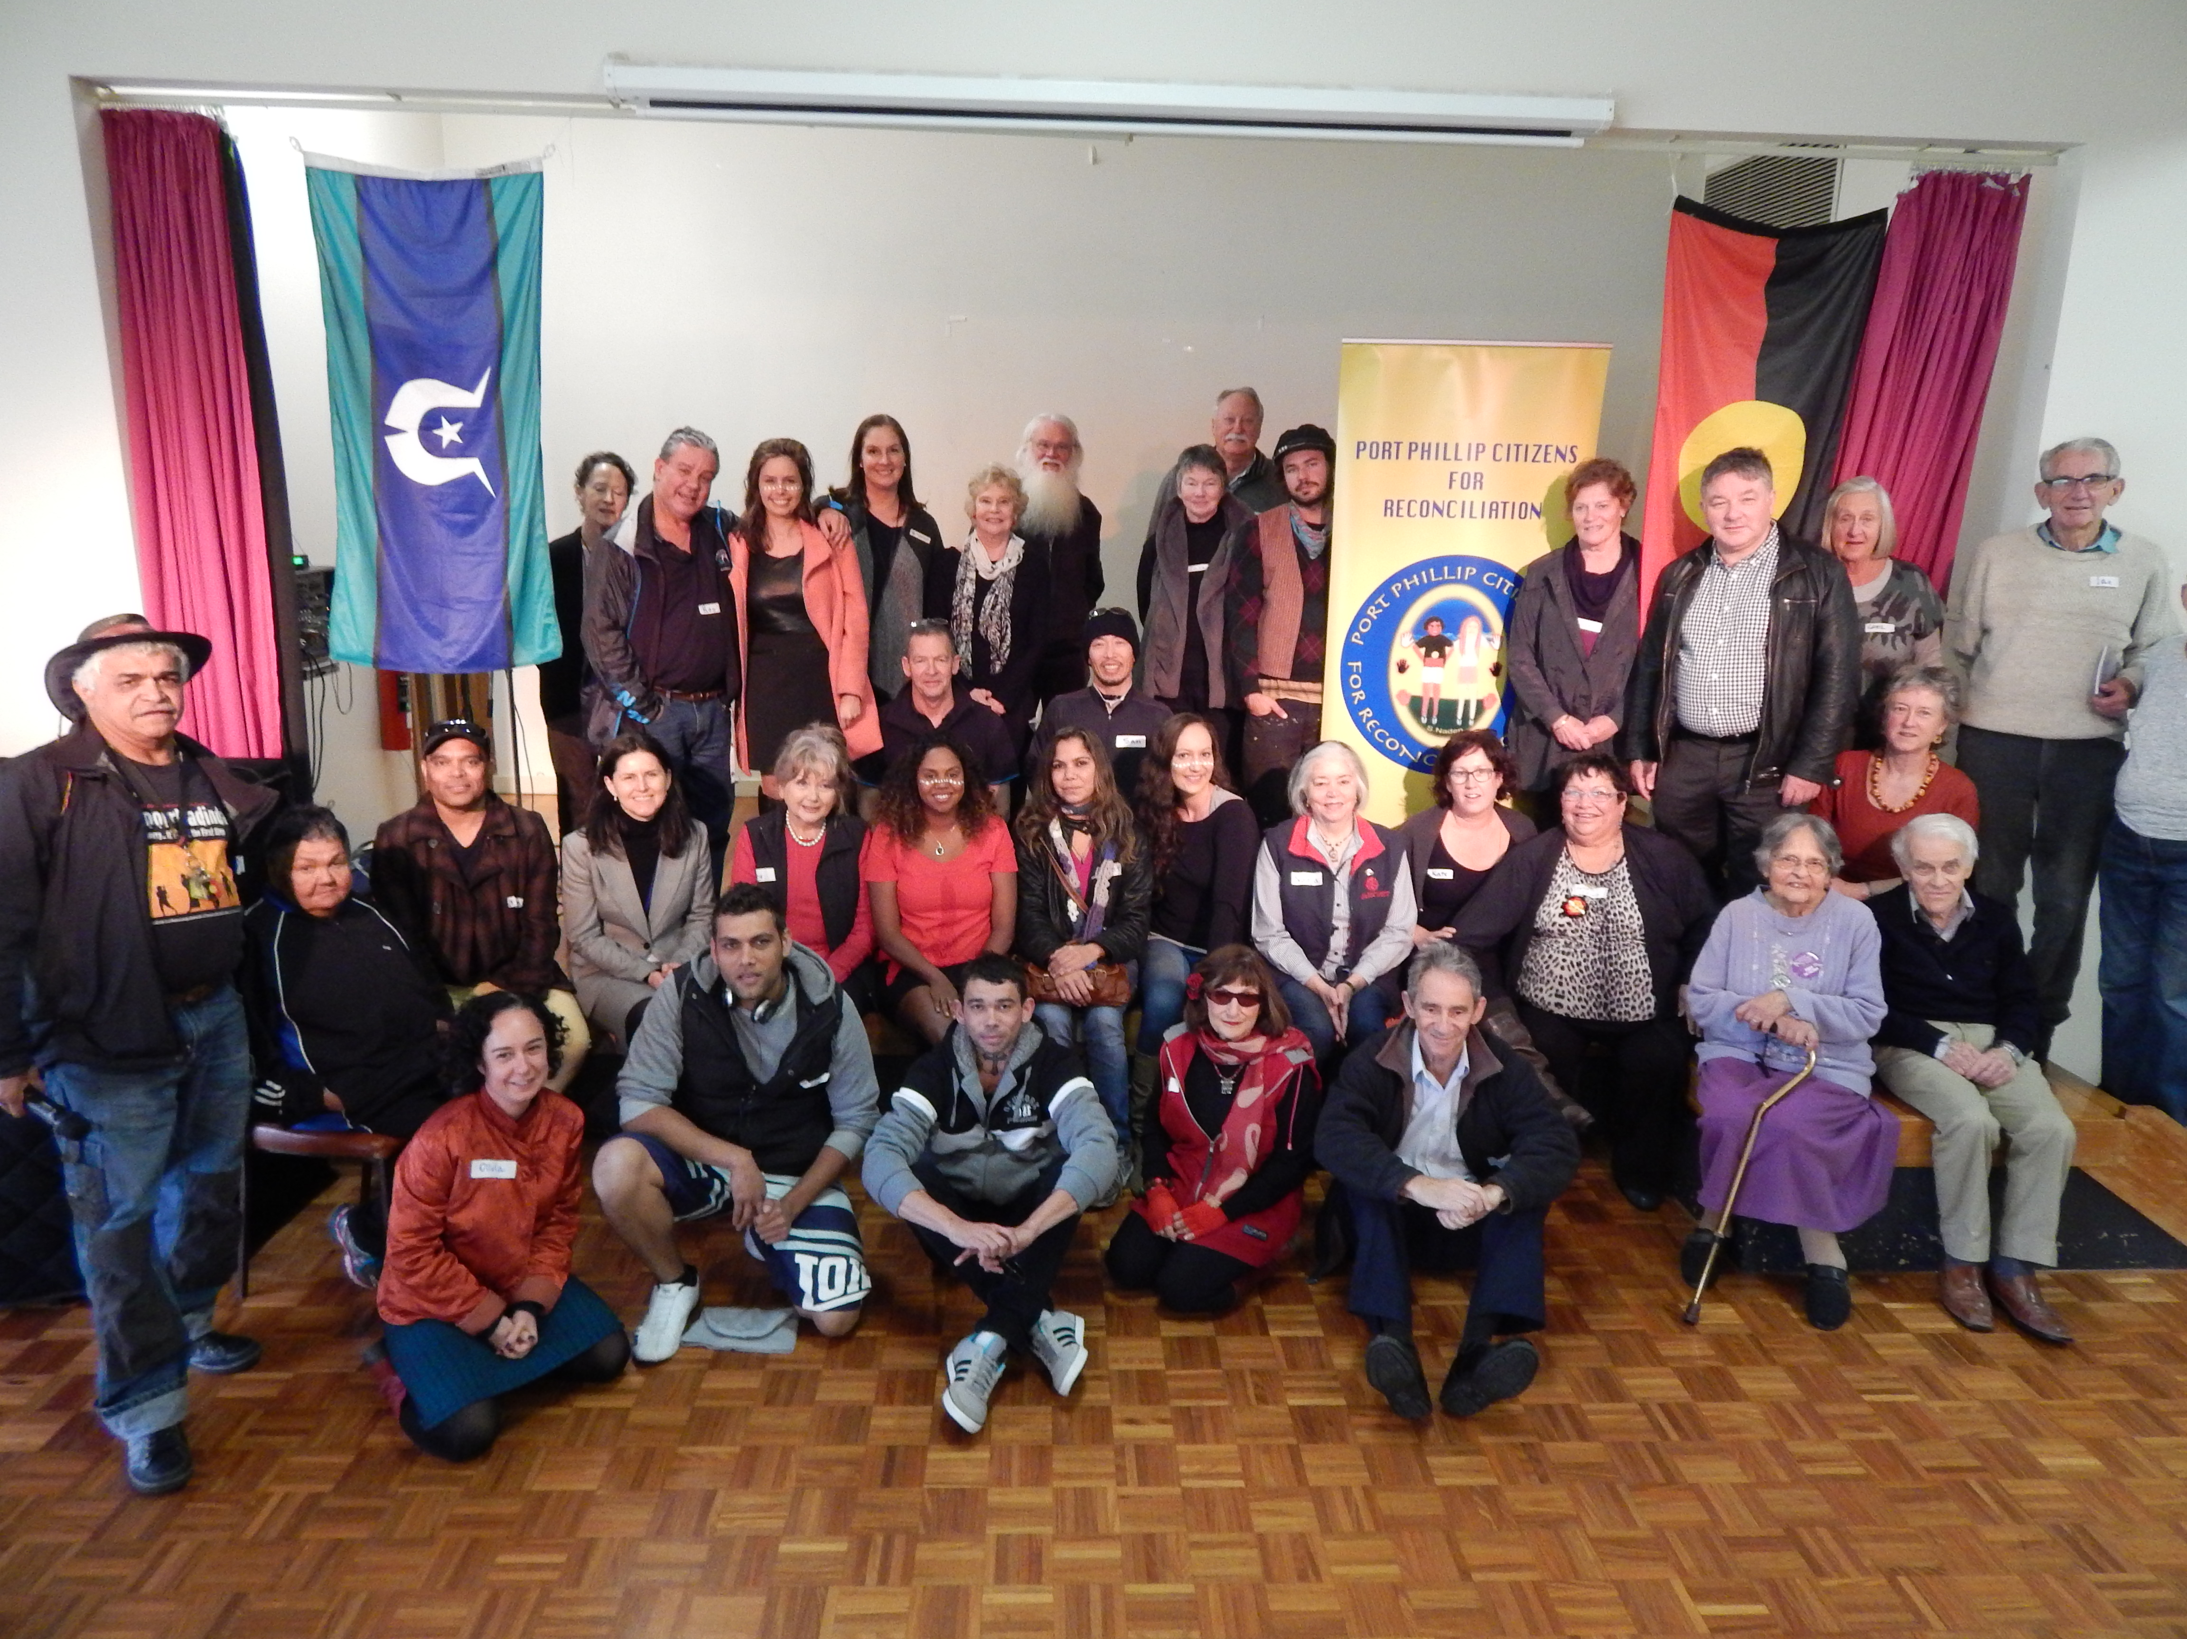
Some of the guests at the 2015 Sorry Day Lunch

PUBLIC EVENTS
2015 Sorry Day Lunch
Described by many as one of the most moving and successful lunches to date, the 2015 Sorry Day Lunch attracted a record crowd of 80 at the South Melbourne Community Centre on National Sorry Day, 26 May. Judith ‘Jacko’ Jackson gave a warm Acknowledgement of Country, and Dennis Fisher was an engaging MC. Guests included Mayor Cr Amanda Stevens, Cr Touzeau, Cr Voss, Cr Thomann, Martin Foley, MP for Albert Park, and, via a read message of support, Sue Pennicuik MLC. They were joined by Elders, community members and PPCfR friends, including life-long stalwarts Noelleen and Harry Ward on the eve of their 60th wedding anniversary.
Stand-out highlights from the lunch were: Sandy Greenwood’s poem about members of her family, all stolen; Declan Furber-Gillick’s rap poem recounting his visit with his father to his grandmother’s grave; and songs from Maurial Spearim and accompanist, singer and guitarist, Brett Lee. A big thank you to Gael Wilson, Denis Frankel, Liz Brumer, Jo Bond, Sylvia Edgar, Liz Gallois, Helen Hoffman, Kerry O’Meara, Meg Davoren-Honey for their help on the day, and also to HEAT caterering.

Port Phillip Volunteer Expo
Jo Bond set up our information stall in St Kilda Town Hall on 6 May that attracted a new member.
Port Melbourne Neighbourhood Centre
On 14 November we engaged Elder Judith Jackson to do an Acknowledgement of County at the opening of the festival.
University of the Third Age (U3A) Middle Park
Jo Bond arranged for Michael Mullerworth to talk about Constitutional Recognition to around 50 members of U3A on 19 August.
Long Walk Women’s Lunch
One of PPCfR’s guests at the Long Walk Lunch on 17 October won a prize; a happy fillip to a memorable event that supports the work of the Long Walk Foundation.
Talks
We heard from two inspiring guest speakers. On 21 April, local historian Meyer Eidelson talked about his new book, Yalukit Willam,
The River People of Port Phillip, attracting
40 people. On 19 May, Dr Bambi Rakhel Ward, a GP and medical educator, spoke about her work with Indigenous medicos.

COMMUNICATIONS
Mungo Newsletter
We produced 11 issues of Mungo reaching over 3,500 people, including RecVic and Stonnington Rec group members. Thanks to Jo Bond and Ian Spalding for doing the snail mail-out, Todd Condie for sending out the email version, and the staff in Martin Foley MP’s electoral office for the printing.
Website
Check out ppcfr.org, which, thanks to the work of Joe Malignaggi, is regularly updated.

NETWORKS
Reconciliation Groups
Several PPCfR members and I have contributed to the local Reconciliation Groups’ forums and AGMs hosted by Reconciliation Victoria (RecVic) and Australians for Native Title & Reconciliation (ANTaR), and a lunch co-sponsored by Recognise on 26 June. I’m pleased to note that PPCfR was included in a Case Study submitted by RecVic to the Office of Aboriginal Affairs Victoria (OAAV).
Your support for the movement both locally in Port Phillip and statewide, and involvement in events and activities, is highly valued and appreciated by the RecVic team.
Stonnington Citizens for Reconciliation Group
Meg Davoren-Honey, Helen Bennett and I attended Stonnington’s Annual General Meeting on 12 August 2014.
Homeless Memorial
We gave financial and in-kind support for their public event at the Peanut Farm, St Kilda, on 17 June 2015.
St Kilda/Elsternwick Baptist Church
PPCfR continued to support the activities of the Church including art exhibitions by Galiamble residents, concerts and an Indigenous Heritage Walk.
Public Service
PPCfR’s Inna Zaitseva, who works as Victorian Reconciliation Representative and RAN member in the Department of Border Protection, engaged filmmaker Richard Frankland to present a talk for staff during NAIDOC Week, and on 18 November, an Indigenous Bush Medicine tour led by BoonWurrung Elder, Carolyn Briggs, and Indigenous educator, Dean Stewart.

FINAL REMARKS AND THANK YOUS
Members
I’m delighted to report that quite a number of people have now signed up as members.
Council Support
We are extremely grateful for the grant and support we get from the City of Port Phillip, especially from Todd Condie, their indefatigable Indigenous Policy Officer. His advice and encouragement are always appreciated. I also applaud the launch of Yalukit Willam, The River People of Port Phillip and Aboriginal and Torres Strait Islander Protocols Framework.
Elwood Community Grant
We were pleased to receive a $2,750 grant from Bendigo Bank and put all the funds towards our schools program. A big thank you to Meg Davoren-Honey for preparing our application.
Looking Ahead
Port Phillip Citizens for Reconciliation will continue to raise awareness about our First Australians through education and working in local schools with students, teachers and providers alike. Over the coming year, we will plan for another public forum on issues relating to the campaign for Constitutional Recognition, invite guest speakers to meetings, encourage interaction with other community groups and reach out to newcomers.
Rosemary Rule, Co-Chair, PPCfR
20 October 2015
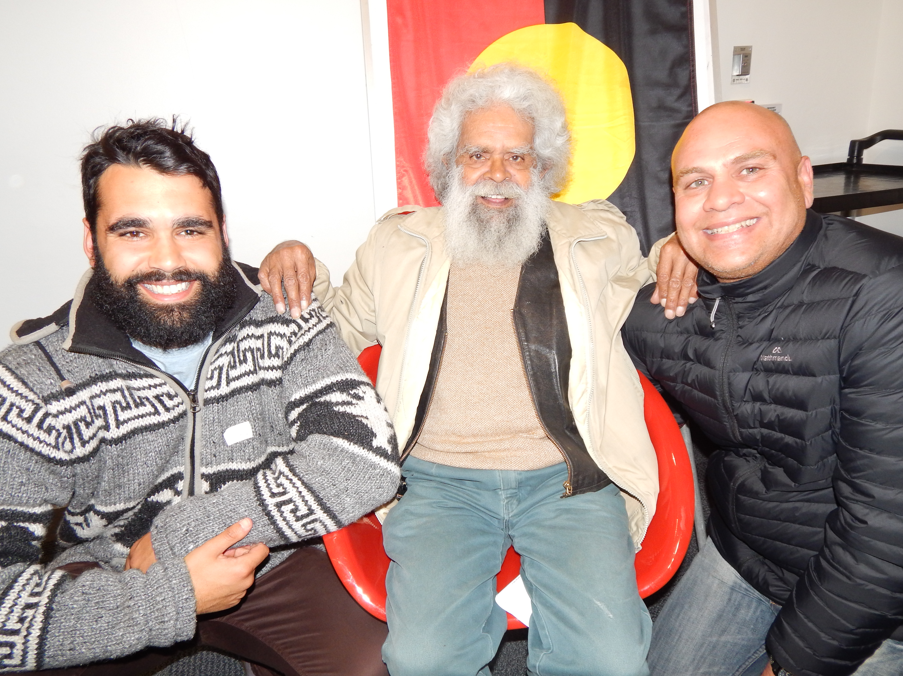
L-R: Daniel Carter (COPP), Uncle Jack Charles and
Todd Condie (COPP)

