2015-2016 Annual Report

Wominjeka! – Welcome

Port Phillip Citizens for Reconciliation acknowledges the Traditional Owners of the land we meet on, the Yalukit Wilam clan of the Boon Wurrung.

Elections
During the previous Annual General Meeting held on 20 October 2015, the following officers were elected unanimously: Co-Chairs - Rosemary Rule and Dennis Fisher; Treasurer - Gael Wilson; Minute-taker - Sylvia Edgar. I’d particularly like to thank them, along with the dedicated band of loyal members who help in so many ways such as with our newsletter, serving at community stalls and events and attending meetings. Without your support this group would not be nearly as effective.

Following the elections, we had an interesting talk from guest speaker Jane Harrison who descends from the Muruwari people of NSW and is a Port Melbourne resident. She spoke about her life and career - writing Stolen and Becoming Kirrali Lewis.

Business
I’m pleased to report that we’ve had good attendances at our monthly meetings with several new people joining us each month. This is most encouraging and the interest shown is appreciated. However, the death of Liz Brumer, a long-time PPCfR member and good friend who died in April, was a sad loss. Our year-end barbecue at Gasworks Park on 12 December was enhanced by the presence of long-time members Noelleen and Harry Ward, with Harry celebrating his 90th birthday.
We have re-nominated Judith Jackson for induction into the 2016 Victorian Aboriginal Honour Roll.

Talks
Ngardarb Francine Riches, an acclaimed artist and sculptor who serves the Melbourne Indigenous Church Fellowship (a church-plant partnership of the Churches of Christ and the Aboriginal Evangelical Church of Melbourne) spoke of her work at our meeting on 21 June. Last month, Chloe Hohneck inspired everyone present with details of the work she does as Reconciliation Team Leader at Elwood Primary School. Todd Condie and Daniel Carter regularly keep us abreast of Council initiatives.

Schools
Throughout 2015 we continued to actively engage with local schools, receiving highly positive feedback for our program of inviting Indigenous Cultural Providers to go into schools, so ably coordinated by Gael Wilson with help from Deb Stewart and Kerry O’Meara. Visits were arranged to Mac.Robertson Girls’ High School’s Assembly and Year 11/12 Legal Studies class; Gowrie Victoria’s Childcare Centre in Docklands; Middle Park and Elwood Primary School, Elwood College and Albert Park College; South Melbourne Mission Kindergarten, Clarendon Street Childcare Centre and Balaclava Kindergarten.
“Students were engaged throughout, including some extra students who heard about our guest speaker and asked to join the class for the session (presented by Daniel Carter, Reconciliation Victoria, to focus on Constitutional Recognition). Ideally all schools would develop a relationship with their local Indigenous community or reconciliation group.”
Robert Corr, Year 11/12 Legal Studies Teacher, Mac.Robertson Girls’ High School.

As of 2016, the BoonWurrung Foundation is handling programs in schools.

National Sorry Day Lunch
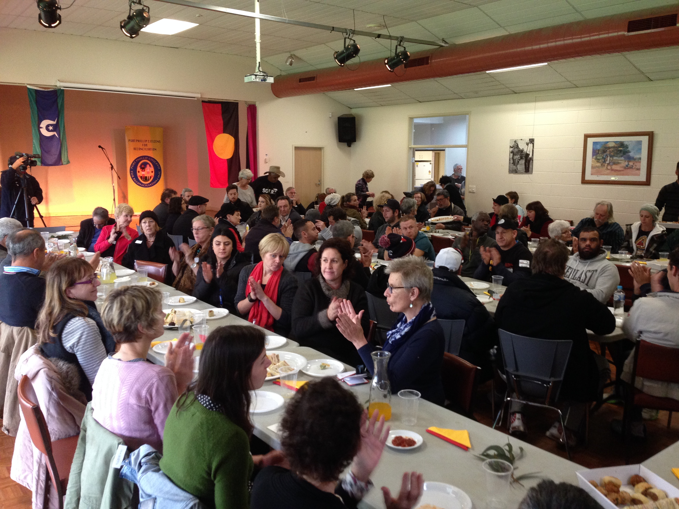

On 26 May, over one hundred people crowded into the South Melbourne Community Centre to commemorate National Sorry Day.
Elder Judith ‘Jacko’ Jackson gave a warm Acknowledgement of Country, and Dennis Fisher’s banter as MC moved proceedings along amiably. Guests included Mayor Cr Bernadene Voss, Councillors Jane Touzeau & Serge Thomann, former councillors Janet Bolitho & Judith Klepner, ISCHS's Kokwam Wapau & Mark Williams, Galiamble's Mark Hammersley, Pastor Digby Hannah, Rev Dr Turi Hollis, Hayley Penrose and RecVic’s Aileen Traynor. Jayden Lillyst was an engaging singer. My thanks to the team of helpers: Gael, Jo, Deb, Fiona, Denis, Andrew, Viv, Helen, Kerry & COPP’s Todd, Jacek, Daniel & colleagues.

Writing Competition
Our Reconciliation Group Writing Competition, launched on Sorry Day, has encouraged Victorian adults and primary and secondary students to write about building bridges between Indigenous and non-Indigenous Australians. Hundreds of entries have been received from schools in and outside of COPP, as well as from many adults. Thanks to Liz Gallois for coordinating this major project and to Gael Wilson, Deb Stewart, Yosefine Deans and Fiona for helping. The entries will be judged by author Jane Harrison and Professor Clare Bradford, and the winners will be announced on 22 November 2016.

City of Port Phillip (COPP)
Members have participated in many Council activities. They helped promote and support the Yalukit Wilam Ngargee in O’Donnell Gardens held on 6 February and attended Reconciliation Week & NAIDOC Week flag-raising ceremonies and associated events held on 27 May and NAIDOC Week 3-10 July. PPCfR, a stakeholder in COPP’s Reconciliation Action Plan (RAP), have actively supported the implementation of the first RAP and, more recently, development of their second RAP.

Port Phillip Volunteers Expo
On 11 May, Jo Bond set up our information stall in St Kilda Town Hall which attracted a new member.
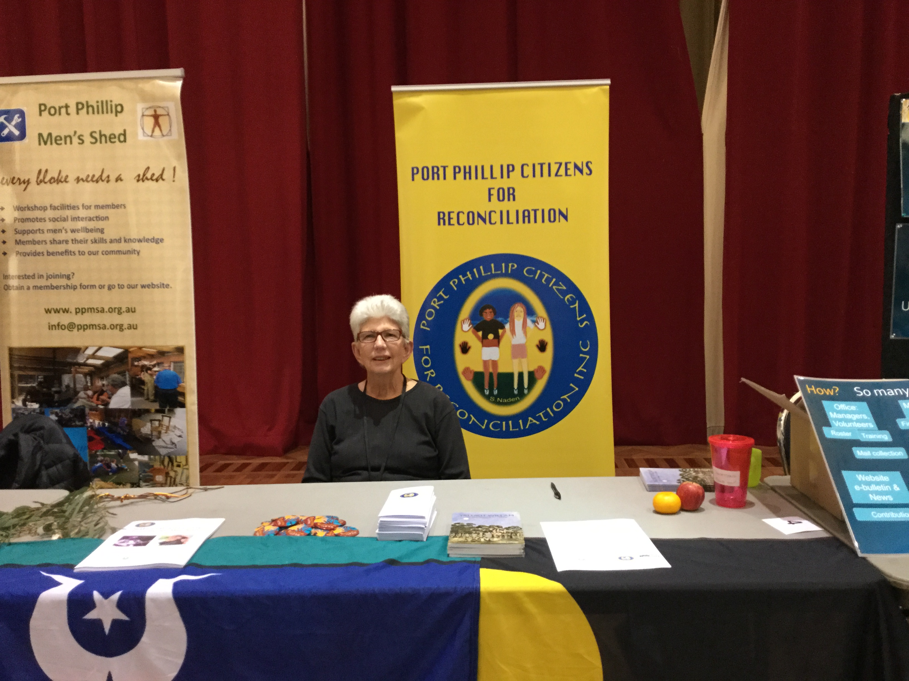
Jo Bond hosts our Volunteers Expo stall.

Emerald Hill Festival
Thanks to Helen, Meg and Fiona for helping at the stall on 15 November. Peter Judda Mackey helped with body painting and happily extended his time to cope with the many children seeking his handiwork.

Communications
Mungo - We produced eleven issues of our Mungo newsletter which reaches more than 3,500 people including RecVic and RecStonnington members. Jo Bond and Ian Spalding do an excellent job with the snail mail outs, and I’d also like to thank Todd Condie for sending out the email version, and Martin Foley’s electoral staff for printing the newsletter.
New brochure - PPCfR has an up-to-date brochure designed by Fiona which is a valuable asset.
Website - Huge thanks to Joe Malignaggi who keeps our ppcfr.org site updated and well maintained.

Long Walk Women’s Lunch
We supported this fundraiser on 16 October for the Long Walk Foundation by hosting a table of 10.
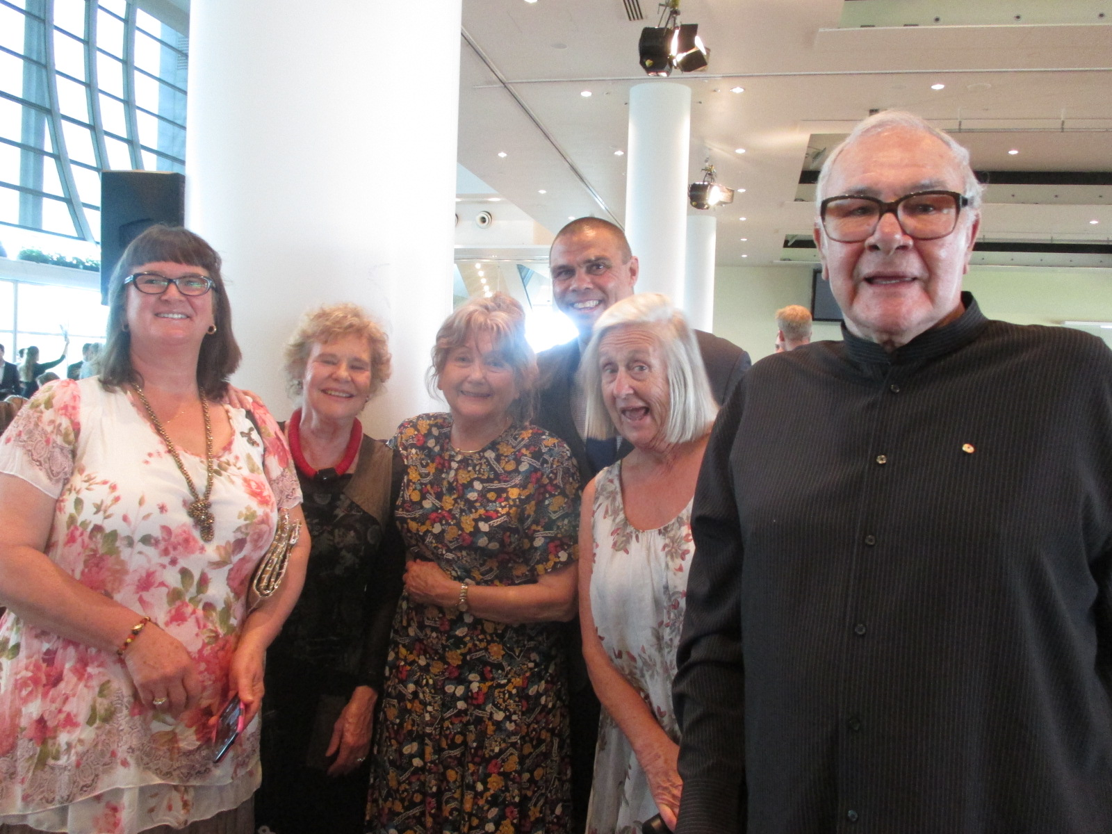
(L-R) Sylvia Edgar, Rosemary Rule, Meg Davoren-Honey, Kyle van der Kuyp, Gael Wilson and Noel Tovey at the Long Walk Lunch

Networks
Reconciliation groups - PPCfR is always well represented at the Local Reconciliation Groups’ forums hosted by RecVic and ANTAR and at their AGM held on 10 October. We report on our activities and those of COPP and hear what other groups are doing around the State. On 16-17 April, Sylvia & Gavin Edgar, Helen Bennett, David Collis and I attended their marvellous weekend forum at Budj Bim, Lake Condah. Meg Davoren-Honey attended RecStonnington’s AGM on 8 September.
Homeless Memorial - We gave financial support to this important annual event held on 22 June.
Torch Foundation - We attended exhibitions earlier this year by Torch artists at Alliance Francaise and at Confined 7, part of Yalukit Wilam Ngargee.
St Kilda/Elsternwick Baptist Church - We continued to support the church’s activities including an art exhibition by Galiamble residents on 14 October.
Christ Church St. Kilda - Reverend Dr Turi Hollis, who attended our Sorry Day Lunch, invited me to speak about PPCfR to his congregation on 29 May.
Jewish community - On 11 October, I introduced Leila Gurruwiwi to members of the Progressive Judaism group who then invited her as a panellist at their forum on Aboriginal Constitutional Recognition.
Elwood Community Bank Grant - We were grateful for $2,161.50 towards our work with schools. Thanks to Carole Mackie and Elwood Community Services.

Council Support
Grateful thanks to COPP for their grant and the strong support we receive. I particularly commend Indigenous Policy Officer Todd Condie for his outstanding work which has such a positive impact, and congratulate Daniel Carter on his appointment as their Reconciliation and Health Promotion Cadet.

Looking Ahead
2017 marks PPCfR’s 20th birthday - how to celebrate this milestone? We’ll be hosting a fundraising art exhibition, a writing competition, presenting a public forum on Treaty-related issues, connecting with community groups and looking forward to meeting our loyal members.

Rosemary Rule, Co-Chair, 18 October 2016

