2019-2020 Annual Report

Wominjeka – Welcome

Port Phillip Citizens for Reconciliation respectfully acknowledges the Yaluk-ut Weelam Clan of the Boon Wurrung. We pay our respect to their Elders, both past, present and emerging, and acknowledge and uphold their continuing relationship to this land.

Annual General Meeting
The AGM, held in the Emerald Hill Library on 26th November 2019, got off to an ideal start with local Elder Judith ‘Jacko’ Jackson giving us a warm Acknowledgement to Country. I read out my Chair’s Report and Fiona Olney-Fraser outlined her very comprehensive Treasurer’s Report. Both reports were moved and accepted by those present. The election of officer bears serving on PPCfR’s Committee - Co-Chairs Rosemary Rule and Dennis Fisher; Treasurer Fiona Olney-Fraser; Secretary Deb Stewart; and Committee Members Jo Bond and Denis Frankel, were unanimously re-elected. I’m deeply grateful that each of them are so supportive and help this wonderful group to maintain their strong and effective presence.

Unfortunately, our guest speaker Diana David, Chair of Reconciliation Victoria, was due to family matters, a last-minute cancellation; a quick bit of improvisation was in order. We shared ideas about how we might work together and extend our reach into communities. Michael Scott, from Uniting Community’s program spoke about finding pathways to develop, and as a recently elected member of Reconciliation Stonnington’s Committee, talked about potential plans he would like to explore. Jacko mentioned some of the many community activities she is involved with, such as Vege Out. COPP Deputy Mayor Cr Tim Baxter presented the group with a Certificate of Appreciation “in recognition of your ongoing commitment to the Community and the City of Port Phillip”. This was unexpected but highly valued.

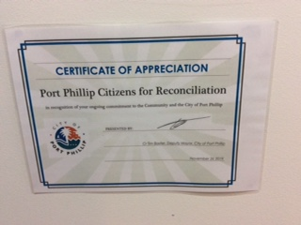

Activities
It is not an understatement that due to the Covid 19-pandemic, 2020 has been a year like no other. Fortunately, before it hit, we had hosted a hugely successful public forum, ‘Treaty-A Community Conversation’, in the St Kilda Town Hall on 22 August 2019. The large crowd of some 140 people had the privilege of hearing from keynote speaker Richard Frankland who is always so informative, educative and entertaining, from Boon Wurrng Elder Janet Galpin, RecVic CEO, Diana David and RecVic Secretary Keith Gove. We organised an end-of-year barbecue for members and friends at Gasworks Park in December and it was terrific to meet some newcomers who joined us. However, all other planned activities for this year, such as our traditional Sorry Day Lunch, 2020 Reconciliation Writing Competition and a Treaty-related forum, along with face-to-face monthly meetings, had to be cancelled in accordance with Covid restrictions.

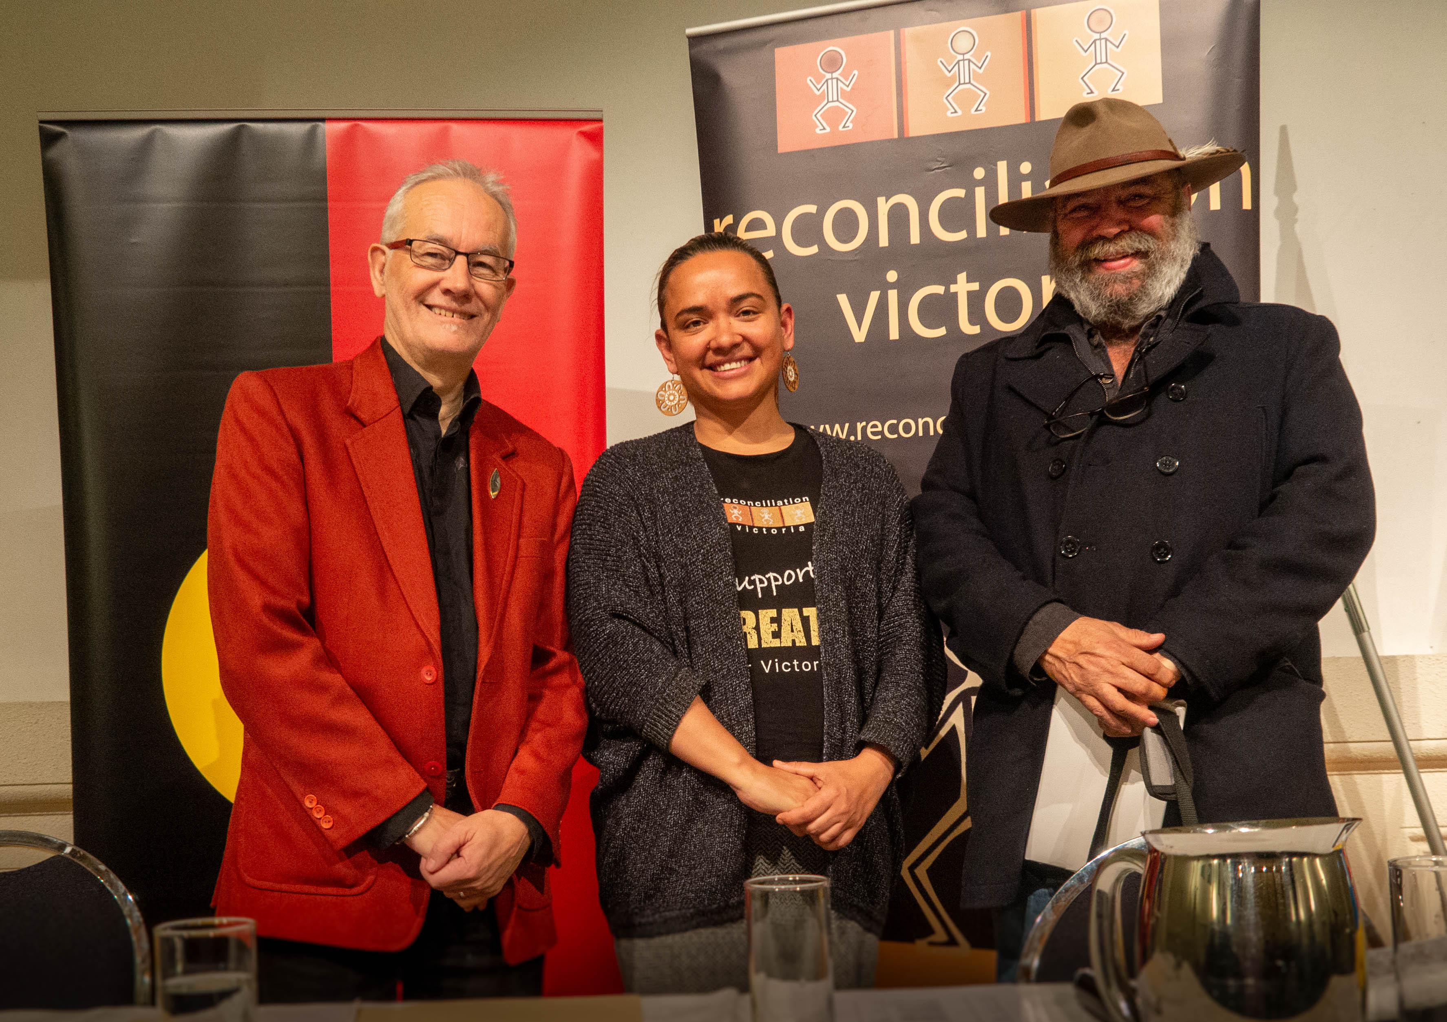
Keith Gove, Diana David, Richard Frankland

Thankfully, it has not all been bad news. I would like to thank Deb Stewart who has managed so well our meetings via Zoom each month. Encouragingly, we have received several enquiries from people wanting to learn more about Aboriginal history and culture, many of whom have since become involved with the group and joined in our meetings. I’ll be looking forward to meeting them in person once the pandemic restrictions have been lifted.

Networking
PPCfR continues to look for and grow connections with other locally based organisations.
St Michael’s Grammar, St Kilda: Dennis Fisher, PPCfR Co-Chair, was invited to address the whole school assembly on 12 August 2019 and by all reports, captivated the students and teachers. COPP’s Todd Condie and Jason Sutardy accompanied Den (see photo below). What made the invitation so special was that it came after St Michael’s students and staff attended our 2019 Sorry Day lunch. Den, as the masterful Master of Ceremonies, had encouraged the students to get up and talk about their views on reconciliation.
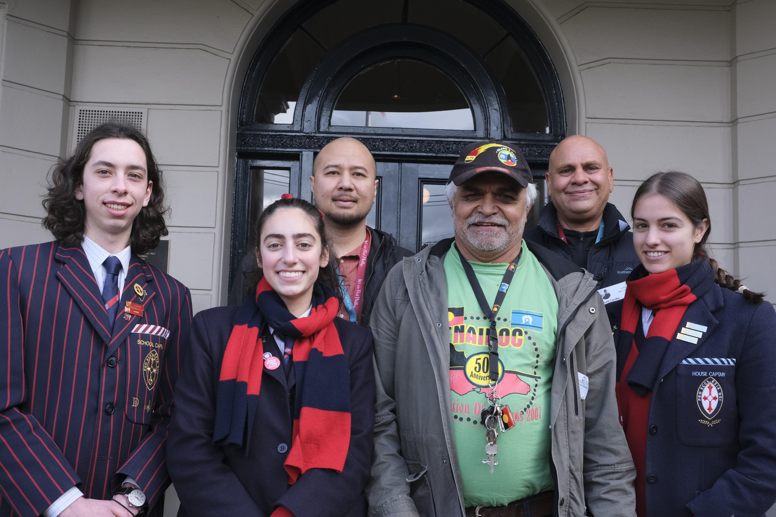

Children’s Garden Kinder: Port Phillip Elder Judith Jackson and I were delighted to be special guests at a gala ball on 12th October. It was hosted by this South Melbourne-based Steiner child care centre in support of the Miriam Rose Foundation, a not-for-profit organisation working to empower Indigenous youth through education, art, culture and opportunity, located in the NT’s Daly River region. Subsequently, the kinder has been incorporating Indigenous-related content into their curriculum. They have also reached out to Dennis Fisher and Judith Jackson to visit and two staff members have joined PPCfR and continue to maintain contact.

Rec groups: Last October, PPCfR members Helen Bennett, Moira Burke and I attended the combined AGM for the peak bodies, Reconciliation Victoria and ANTaR Victoria. Guest speakers included Thomas Mayor from the Uluru Statement from the Heart and Lidia Thorpe, Victoria’s first female Aboriginal parliamentarian.

Star Health: PPCfR members agreed to donate $1,500 to the organisation specifically to assist their Indigenous Access and Community Connections Care Package programs delivered during the Covid pandemic.

St Kilda/Elsternwick Baptist Church: We continue our close association with the Church, support their annual exhibitions with artists from Galiamble and Winja Ulupna and report on their various activities in Mungo.

Guest Speakers
Michelle Griffiths attended our monthly meeting July 2019, telling us about the importance of native dingoes and the need to preserve their species. As Council closed our regular gathering place, the South Melbourne Community Hub in February, all guest speaker engagements – and meetings – have stopped.

People
I pass on my condolences to the family of Vivienne McCutcheon, a founding PPCfR member, who passed away on 28 July 2020 and who will be greatly missed. I valued Viv’s wisdom and her generosity to sponsor a prize in our 2018 Reconciliation Writing Competition.

Communications
Mungo, our monthly newsletter, continues to cover a range of news and relevant events, circulated annually to over 3,500, and electronically to Reconciliation Victoria and Reconciliation Stonnington members.

I am grateful to the staff in Martin Foley’s electoral office who print out Mungo for members on the snail mail list. Thank you Jo Bond for uncomplainingly doing the physical mail outs; to Todd Condie at the Council who emails out the online version - invariably accompanied by an interesting note - and to Joe Malignaggi who posts the newsletter on line. Joe also diligently maintains and updates the ppcfr.org website.

City of Port Phillip (COPP)
Surely one of the most original and inspiring events of 2020 was the We-Akon Dilnja, or Mourning Reflection event, hosted by the City of Port Phillip from 6.00am on 26th January in St Kilda’s Alfred Square. Many members were among the large crowd listening to speakers representing the Boon Wurrung, the Aboriginal community, faith groups and the Council. I sincerely hope this memorable and important event will become an annual fixture.

The Council, under the guidance of Todd Condie, their hard-working Indigenous Policy Officer, ably assisted by Aboriginal Health and Reconciliation Officer Jordan Sutardy, continue to network widely and develop their third Reconciliation Action Plan. PPCfR is a core member of their RAP working group and I am invited to their meetings. Some virtual activities were arranged during Reconciliation Week and NAIDOC Week.

I am most grateful for the grant our group receives, enabling our work to continue, and also for the personal support received from Councillors and staff.

Looking Ahead
It’s not easy during lock down to think about the future but we will keep going! We will present a Reconciliation Writing Competition for adults and students in 2021, host a National Sorry Day lunch, hold a public forum, and continue to welcome newcomers and to share ideas.

In closing, I wish to thank the Committee, particularly the core group. They include Jacko, Todd, Jordan, Fiona, Deb, Sushena, Jo, Gael, Moira, Joy, Janine, Digby, Helen and Denis, as well as our newer members who willingly give up their time to support our work. Together this inspiring bunch helps ensure that PPCfR continues to be an effective community group committed to promoting the reconciliation process.

Rosemary Rule, Co-Chair, 20 October 2020.

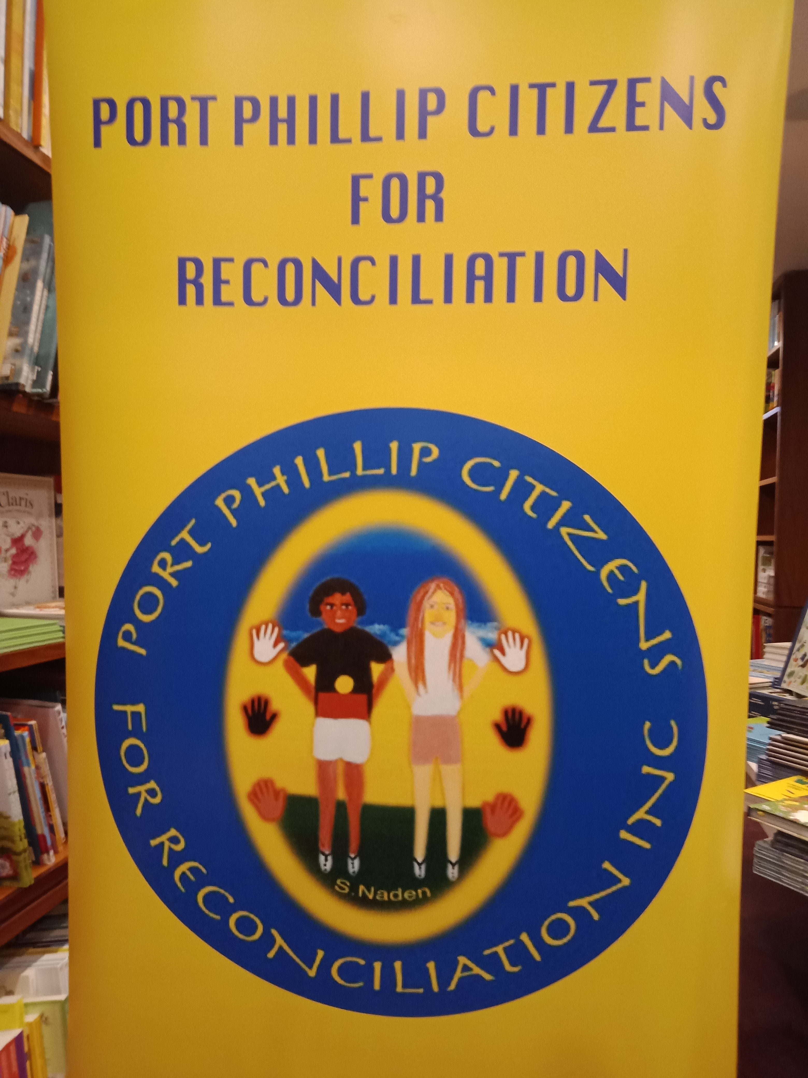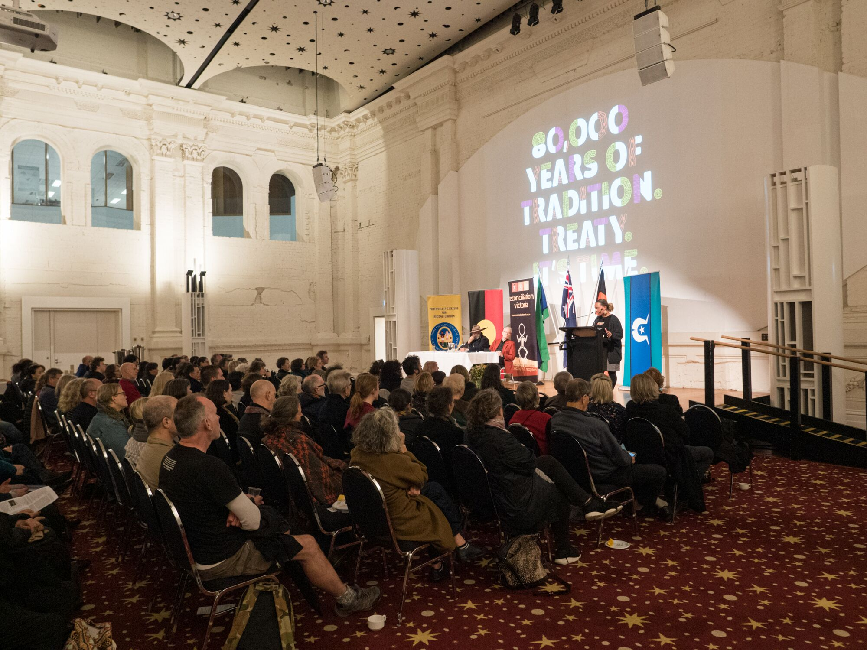

PPCfR Treaty forum 22/8/2019
attendees

